- Meet the New Believers
IMAGE: Collage of the ULCH Glee groups

- Full of hope, promise and perseverance.
IMAGE: Inspiring. Happy, on top of the mountain, climbing tall stairs

- With dreams of bringing the best performance ever!
IMAGE: 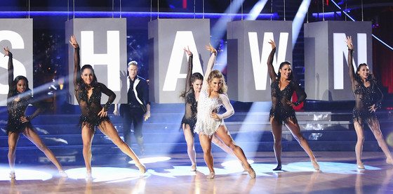

- They get a task. They act on it…and they act on it with force.


- There’s no stopping these guys.
IMAGE: Running

- Despite the hurdles
- No holidays since last year
IMAGE: Missing the family, Christmas icon with x mark
- Confusion with the choice of songs
IMAGE: Confused person, angry, photo of microphones
- A load of last minute changes
IMAGE: Song notes/key note, song titles (from Glee)
- Questions on technical details because of its impact to a spectacular performance
IMAGE: wiring, speakers, fireworks, confetti
- Cost of costumes and props
IMAGE: Peso signs, costumes, props
- Questions on guidelines and mechanics, to make sure everything are just right!
IMAGE: papers, words on screen: guidelines, mechanics, 50 points (text --- this is the high score)
- Hired professional choreographers / consultants
IMAGE: dance instructor, group following instructor in front
- Late rehearsals up to wee hours of the night
IMAGE: sleepy, tired, pawisan, 12MN
- Health sacrifices because of late nights
IMAGE: super tired, pale, hilo face
- Physical pain due to rehearsals
IMAGE: bandages, band aid, first aid
- They still took their time intensely rehearsing
IMAGE: people dancing sweaty
- In order to present
- The most spectacular of performances
- So never stop believing. Because dreams do come true.
- If you’re like these guys
IMAGE: COLLAGE OF ULCH PHOTOS (bawas from the first collage)
- Then you’ve got what it takes!
- Presenting the dreamers…
IMAGE: Use the old slides --- intro of group performers. Glee Groups (same photos)
  - Gutsy Gold
  - Blue Bold
  - Gung-ho Green
  - Purposeful Purple
  - Resilient Red
- Expect something big. Expect the Unexpected.
IMAGE: Gleevolution

